**Font Helvetica or Arial**

no serif font (z.B. Times)

Font size minimum 14 Punkt

This block is max. 12 cm wide

**optional Logo**

**only black & white**

no color or grayscale

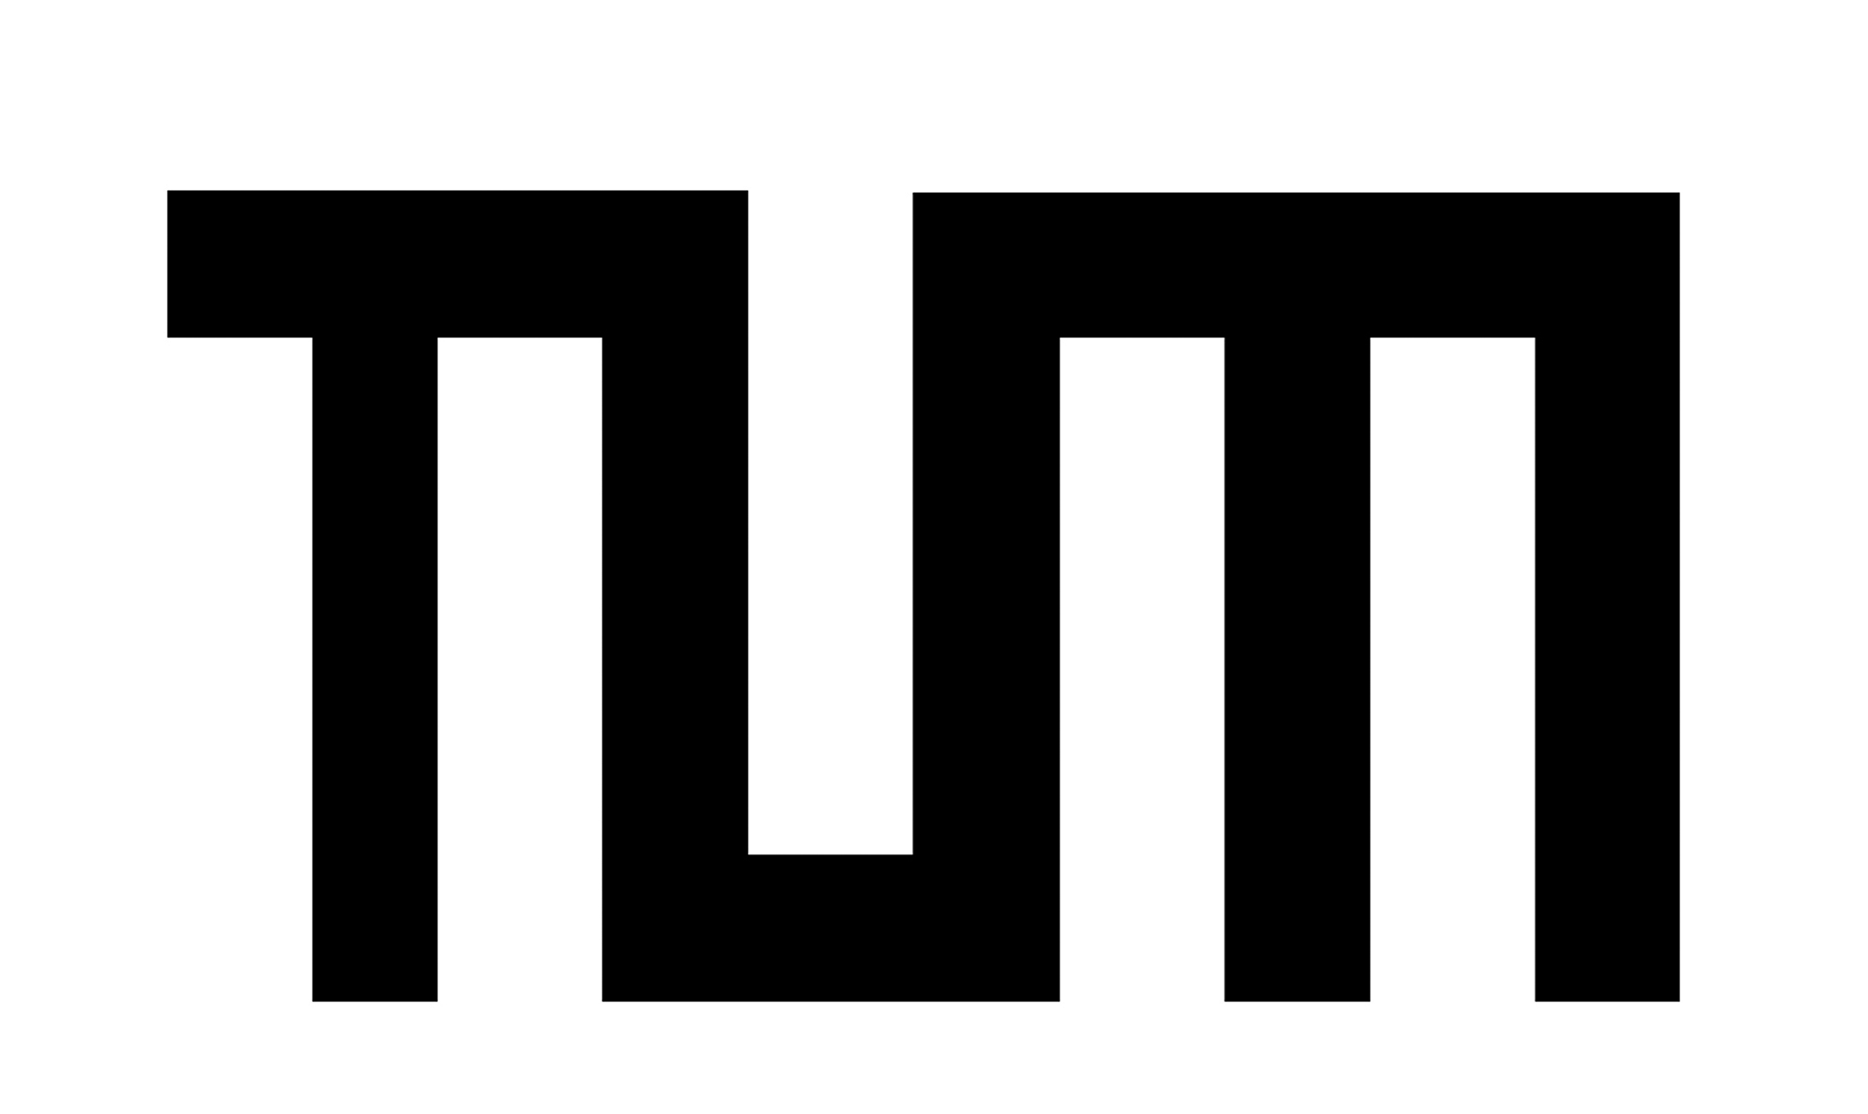 Example

**Optional Block**

This block is max. 12 cm wide